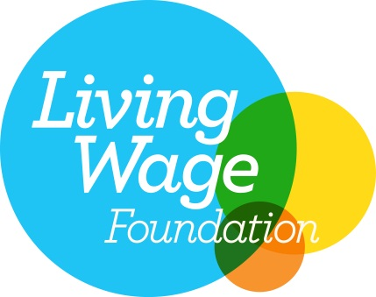
PRESS RELEASE

FOR IMMEDIATE RELEASE

BLUEFRUIT CELEBRATES LIVING WAGE COMMITMENT

The Living Wage Foundation is pleased to announce that Bluefruit Software, is now accredited as a Living Wage employer.

The Living Wage commitment will see everyone working at Bluefruit, regardless of whether they are permanent employees or third-party contractors and suppliers; receive a minimum hourly wage of £7.85 - significantly higher than the national minimum wage of £6.50.

The Living Wage is an hourly rate set independently and updated annually. The Living Wage is calculated according to the basic cost of living using the ‘Minimum Income Standard’ for the UK. Decisions about what to include in this standard are set by the public; it is a social consensus about what people need to make ends meet.

Steve Forth, General Manager of Bluefruit Software said: “While we have always paid our employees above the living wage as standard, it’s brilliant to make a formal commitment and be recognised for paying above and beyond what we believe is a fairer minimum than NMW.”

Employers choose to pay the Living Wage on a voluntary basis. The Living Wage enjoys cross party support, with public backing from the Prime Minister and the Leader of the Opposition.

Living Wage Foundation Director, Rhys Moore said: “We are delighted to welcome Bluefruit to the Living Wage movement as an accredited employer.

“The best employers are voluntarily signing up to pay the Living Wage now. The Living Wage is a robust calculation that reflects the real cost of living, rewarding a hard day’s work with a fair day’s pay.
“We have accredited over 1,500 leading employers, including Bluefruit, ranging from independent printers, bookshops and breweries, to well-known companies such as Nationwide, Aviva and SSE. These businesses recognise that clinging to the national minimum wage is not good for business. Customers expect better than that. "

ENDS

Media Contacts
Living Wage
Gillian Owen, 07876 246 150, gillian.owen@citizensuk.org.uk

Bluefruit Software
Anna Clark, 0333 5777 111, info@bluefruit.co.uk

Notes to Editors

About the Living Wage Foundation

The Living Wage is an hourly rate set independently and updated annually. The Living Wage is calculated according to the basic cost of living in the UK. Employers choose to pay the Living Wage on a voluntary basis. The Living Wage enjoys cross party support, with public backing from the Prime Minister and the Leader of the Opposition.

The London Living Wage is currently £9.15 per hour. This figure is set annually by the Greater London Authority and covers all boroughs in Greater London. The UK Living Wage for outside of London is currently £7.85 per hour. This figure is set annually by the Centre for Research in Social Policy at Loughborough University.

The Living Wage Foundation recognises and celebrates the leadership shown by Living Wage employers across the UK. There are currently over 1,500 accredited employers. We are an initiative of Citizens UK. We believe that work should be the surest way out of poverty.

